**Bug Report**

Summary – User is able to submit the form even when the message text box is empty.

Description – When a user submits a form of marketing type, and leaves the message text box as empty, the form gets submitted without even error.

**Actual result** – User is able to submit the form even when the message text field is empty.

**Expected result** –User should get an error when message text field is left empty and clicked on submit button, attaching image for reference-

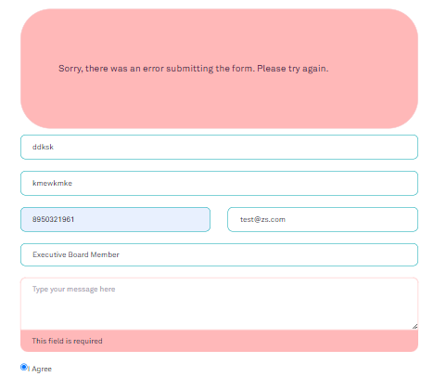

**Steps to Reproduce –**

1. Go to <https://www.tendable.com/>
2. Click on contact us button present on the right top side.
3. Click on contact button in marketing tab.
4. Fill the details except the message field.
5. Click on submit button and observe the UI behavior.